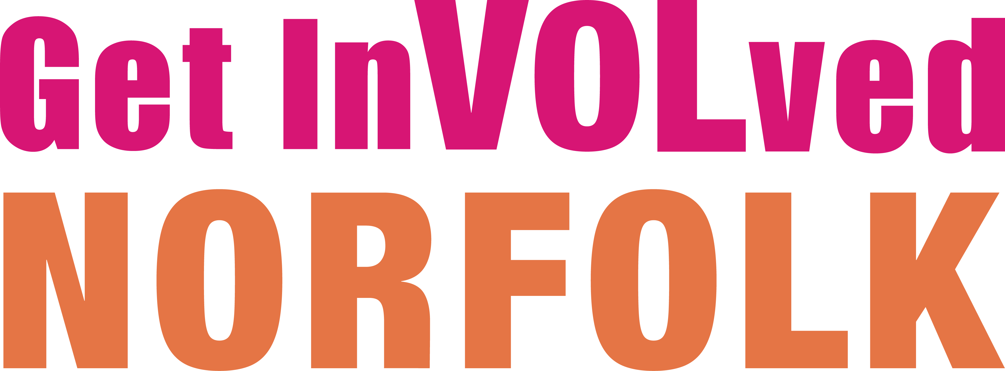
Organisation Agreement

Get InVOLved Norfolk is a volunteer recruitment platform providing a space for organisations to advertise voluntary vacancies across Norfolk and along its borders.
For the recruitment of volunteers the site is open to any approved volunteer involving organisation and all voluntary, community and social enterprises looking to recruit volunteers in Norfolk and along its borders, this also includes those listed below:
- Registered charities
- Community groups
- Social Enterprises
- Independent employee/member/retired persons social associations
- Sports and leisure clubs and societies
- Parent / teacher associations and out of school clubs
- Independent ‘friends of’ associations or similar
- Public sector organisations such as hospitals and libraries that engage volunteers to enrich their services.
- Faith organisations

Please complete this form to confirm you have read and accepted this agreement.
When registering on Get InVOLved Norfolk, we assume you have in place appropriate and regularly reviewed policies, procedures, and insurance to cover volunteer activities.
If you need any support regarding policies, procedures and insurances please visit our resources section via this link

Please note: Voluntary Norfolk is not responsible for the content of your policies or for verifying that appropriate insurance or other compliance requirements are in place. Responsibility for ensuring these remain valid and up to date is with your organisation.

