Get InVOLved Norfolk
How to create your account

You can use Get InVOLved Norfolk to look at the different volunteering roles across Norfolk. You can look at all available opportunities or narrow your search to a specific area or type of role.

Creating an account is very simple and will enable you to apply for volunteering roles, contact organisations and save interesting opportunities, all on the same website.

To create an account, please follow the steps below:

- Navigate to www.getinvolvednorfolk.org.uk.

- Click “Create account” at the top of the screen.
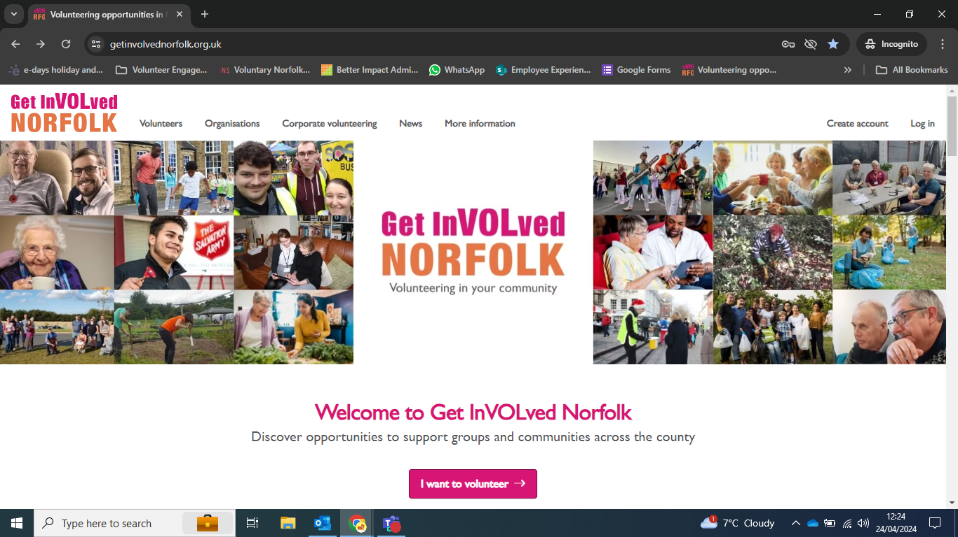

- Complete the mandatory fields to create your account. You will need an active email address which you can reliably access.

- After confirming your details, you will be able to look for and register for opportunities across Norfolk and Waveney.

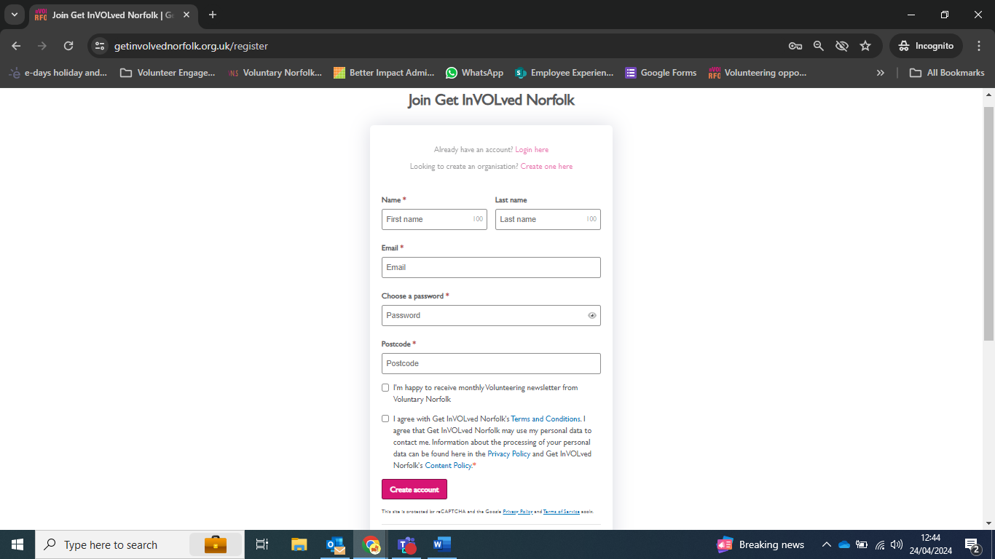
Tick this box so you can get the newsletter all about volunteering

When you click on a role advert it will give you more details about the role. There is also a ‘Contact Person’.
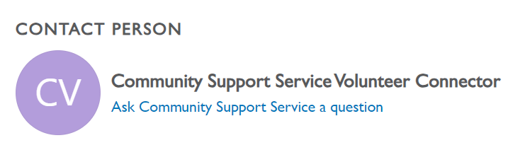
If you want to ask a question before applying, you can use this link. It sends a message to the organisation. This ‘Ask a Question’ button is on the right-hand side of the page.
They will email you back.
Remember! Check your email regularly.

