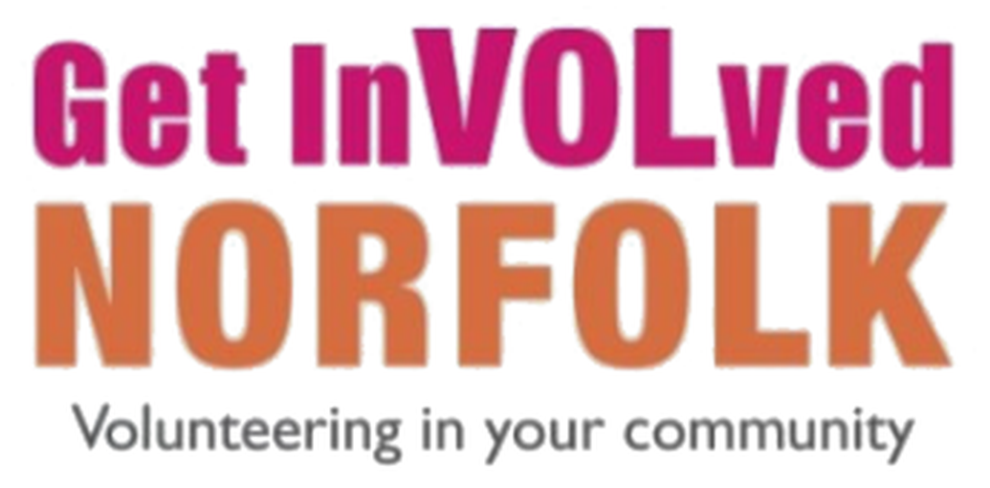

How to create your organisation page on Get InVOLved Norfolk
This guide explains how to set up your organisation’s page so that you can advertise volunteer roles and connect with potential volunteers. It takes about ten minutes.

Before you start
You will need:
- your own Get InVOLved Norfolk account (you must be signed in);
- your organisation’s name and type, and its address and website if you have them;
- a short summary of what your organisation does;
- a square logo as a JPEG or PNG file, no larger than 5 MB. This is required, and you cannot create your page without one;
- optionally, a cover photo (minimum size 940 by 330 pixels). You can add this later.
Your organisation must also have the relevant policies and insurance in place to cover its volunteering activity. We will check this as part of the approval process.

Tip: get approved faster
We aim to approve new organisations the same day, Monday to Thursday. To help us do this, please complete these two things before or straight after you create your page:
- Read the Get InVOLved Organisation Agreement (Word document).
- Confirm that you have read and agree to it by completing the Agreement Confirmation form.
We also send you both links when you create your page, but completing them earlier speeds things up.

Step-by-step instructions

Step 1: Open your profile menu
In the top right-hand corner of any page, find your profile icon. This shows your picture if you have added one, or your initials if you have not. Select it to open a menu of options.

Step 2: Select “+ Create Organisation”
In the menu, look under the heading Organisations. If you already belong to any organisations, they are listed here. At the end of the list, you will see + Create Organisation. Select it to open the form. If the menu is long, scroll down to find it.
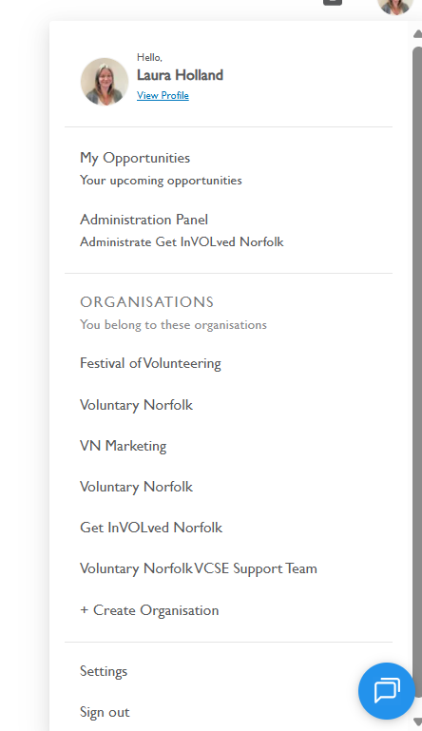
Figure 1: The profile menu. The + Create Organisation option is at the end of the Organisations list.

Step 3: Complete the form
The form is called “Create your organisation on Get InVOLved Norfolk”. Fields marked with an asterisk (*) are required. The full form is shown below, followed by an explanation of each field.
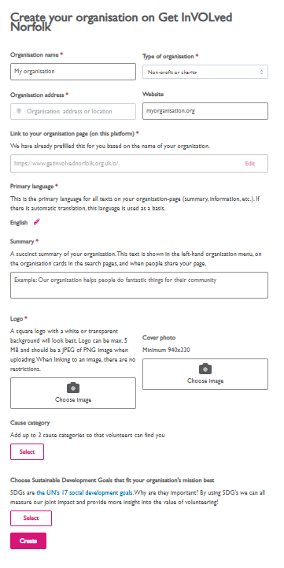
Figure 2: The Create your organisation form. Each field is explained in the table below.
Table 1: Fields on the Create your organisation form
Field | Required | What to do
Organisation name | Yes | Enter the name of your organisation.
Type of organisation | Yes | Choose the option that best describes you from the drop-down list, for example “Non-profit or charity”.
Organisation address | No | Enter your address or location. Area can be used if you do not wish to share your address.
Website | No | Enter your website address if you have one.
Link to your organisation page (on this platform) | Yes | We fill this in for you, based on your organisation’s name. You can change it by selecting Edit.
Primary language | Yes | This is set to English. It is the language used for all the text on your page, and is the basis for any automatic translation.
Summary | Yes | Write a short, clear summary of your organisation. It appears in the left-hand organisation menu, on organisation cards in search results, and when people share your page.
Logo | Yes | Select Choose image and upload your logo. A square logo with a white or transparent background looks best. It must be a JPEG or PNG and no larger than 5 MB. You cannot create your page without a logo.
Cover photo | No | Select Choose image to upload a cover photo (minimum size 940 by 330 pixels). You can add this later.
Cause category | Yes | Select and choose up to three categories that describe your work. This helps volunteers find you.
Sustainable Development Goals | Yes | Select and choose the goals that best fit your organisation’s mission. These are the United Nations’ 17 global goals for social, economic and environmental development. Using them helps us measure our joint impact and show the value of volunteering.

Step 4: Select “Create”
When you have completed the form, select the pink Create button at the bottom. This sends a notification to our team to approve your organisation.

What happens next
- We receive a notification and check your organisation’s details.
- We send you the Organisation Agreement and confirmation form, so that we can check you have the right policies and insurance in place.
- Once you have confirmed that you have read and agree to the agreement, and we have approved your organisation, you can start adding volunteer roles.
We aim to approve new organisations the same day, Monday to Thursday, provided you have read the Organisation Agreement (Word document) and completed the Agreement Confirmation form.

Next: adding your volunteer roles
Once your organisation has been approved, you can start adding volunteer roles. A separate guide on how to do this is available in our resources section here

Need help?
If you get stuck or have a question, please email the Volunteer Centre team at volunteercentre@voluntarynorfolk.org.uk.

