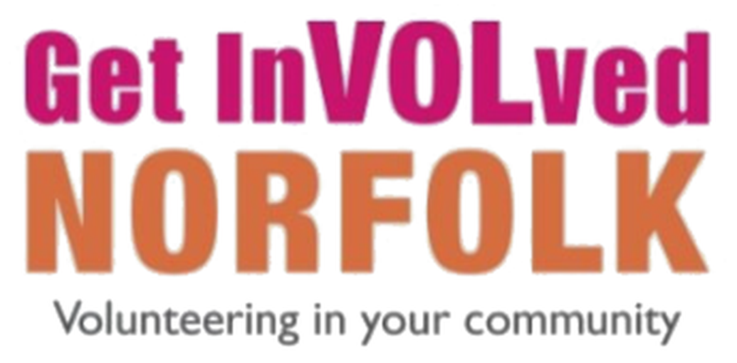

How to add a volunteering opportunity on Get InVOLved Norfolk
Once your organisation has been approved, you can start adding volunteer roles. This guide takes you through the form step by step, with tips to help your role stand out. It covers the basics to get you started, but it is not everything the platform can do.

In brief
- Go to your organisation page.
- Select Add, then choose Volunteering opportunity.
- Complete the form: location, type of role, summary, description, cover image and how people can join.
- Choose the activities, causes and tags that match your role.
- Select Save as draft, check the preview, then Publish.

Before you start
You will need:
- an approved organisation on Get InVOLved Norfolk;
- the details of your role: what volunteers will do, where it takes place, and what they will gain from it; (copy and paste works)
- a cover image for the role, at least 940 by 330 pixels (ideally a different one for each role, so they stand out);
- optionally, a video. It must be on YouTube or Vimeo and publicly available. You only need its web address.

Tip: you can come back to it later
You can select Save as draft at any point while you are filling in the form, then return and finish it later.

Step-by-step instructions

Step 1: Go to your organisation page
Your organisation page may already be your main page when you sign in. If it is not, select your initials or picture in the top right-hand corner, then choose your organisation from the drop-down list.
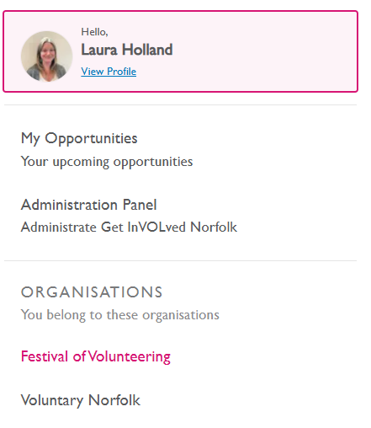
Figure 1: Choose your organisation from the list under the Organisations heading.

Step 2: Add an opportunity
Once you are on your page, there are two ways to start:
- select the Add button, in the bottom left-hand corner of your cover image; or
- select Opportunities from the menu on the left-hand side. This option also shows any current or closed opportunities you have.
Either way, select Add or Add opportunity and choose from the drop-down list. Volunteering opportunity or Community event. This guide is for volunteering opportunities.
Once you have chosen, complete the form with the details of your role. The steps below explain the main parts.

Step 3: Add the location
Enter the location of the role. You can search by postcode, address or city, or use one of the options in the list. You can also choose the city only.
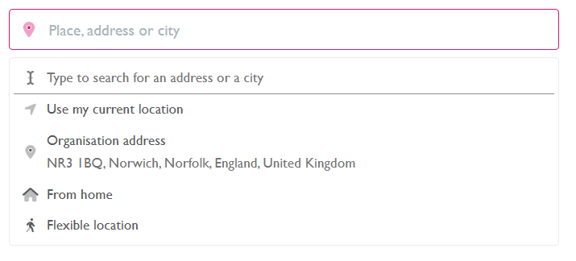
Figure 2: The location options.

Step 4: Choose the type of opportunity
Choose the option that best fits your role:
- One-off: for example, a one-day event.
- Project role (temporary): a short-term role for a campaign or project, for example six to eight weeks.
- Organisation role: a regular, ongoing role.
If you choose One-off, you will be asked for a date and time. If your role does not have a set date, select No date.
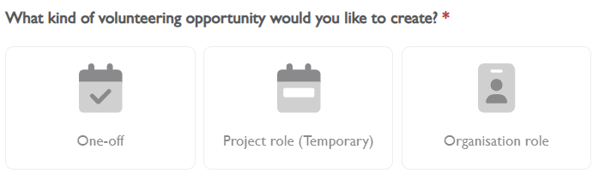
Figure 3: The three types of opportunity.

Step 5: Write a short summary
Keep your summary short and engaging. The aim is to encourage a potential volunteer to open your role and read more. You have 160 characters.

Step 6: Add a detailed description
To add more information, select + Add a detailed description. You can also select + Add extra instructions on how to get to location to add details such as parking and bus routes.
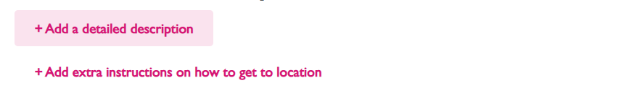
Figure 4: The buttons for adding a description and travel instructions.
The description box is much larger. You can add headings, bullet points, images and videos. The box also gives you a prompt: to get the best match, explain what people will do, what they can gain from the experience, and what impact they will make. Try to keep it short and engaging.
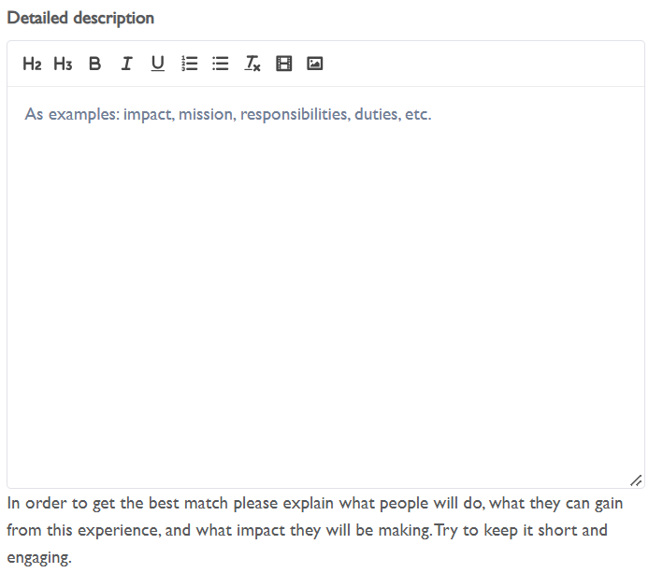
Figure 5: The detailed description box and its toolbar.
Adding a video. Videos must be on YouTube or Vimeo and publicly available. You only need the web address, so no coding or technical knowledge is needed. Copy the address, select the film icon in the toolbar, and paste the address into the box. Make sure your cursor is where you want the video to appear. This is the same for images, they will be dropped in where the cursor is.

Step 7: Choose a cover image
Choose an engaging image. Ideally, use a different image for each role so that they stand out. The recommended minimum size for a cover image is 940 by 330 pixels.

Step 8: Set how people can join
- How many people can join? This is where you can limit the number of applications. We usually advise leaving it unlimited unless you have a specific number of places to fill. You can change it later, so do not worry if you change your mind.
- Is your role suitable for groups of friends, colleagues or a team? If so, select the box. Your role will then appear automatically wherever we are promoting team volunteering on Get InVOLved Norfolk.
- How can people join? Unless you are advertising an event, we recommend you choose Apply. If you choose RSVP, people will show as going, not as applying for your role.
- Custom forms. You can create a form to gather more information from applicants. You do not have to use one, but it is there if you need it. Once a form is created, you can add it to any of your roles.
- Add standard welcome message. We strongly recommend you use this. It sends an automatic message to people when they select the register interest button, so they know their message has been received. It can include links to external sites and forms, or email addresses. You may simply want to say thank you for their interest and that you will be in touch to arrange an informal chat.

Step 9: Choose activities
Select the activities involved in this role, not your organisation as a whole. Choose as many as are relevant. The system uses these, together with postcode, to match potential volunteers with your role. Remember to save your selections before you exit.
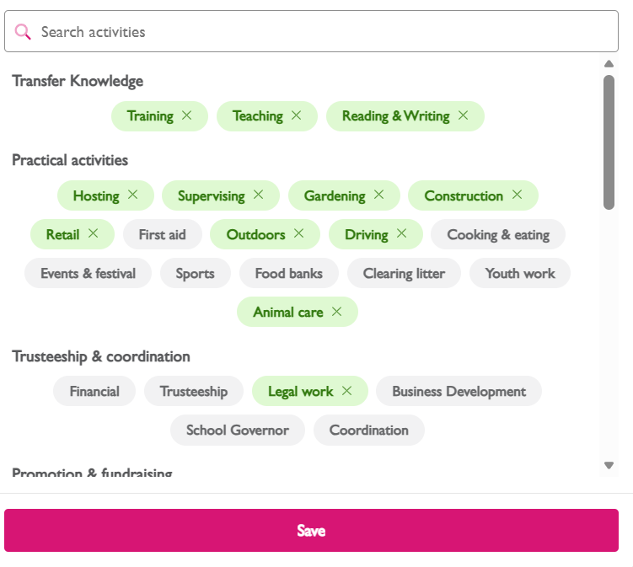
Figure 6: Selecting activities. Chosen activities are highlighted in green.

Step 10: Choose causes
Causes work in a similar way to activities and relate to the role itself. You can only select up to three.
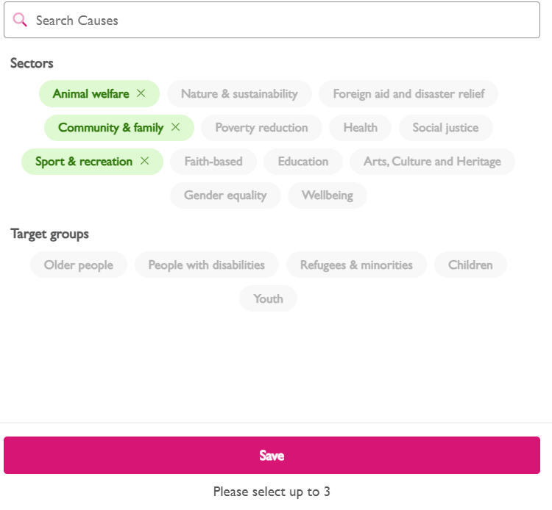
Figure 7: Selecting causes. You can choose up to three.

Step 11: Select tags
If your role is suitable for any of the following groups, select the relevant box. This feeds your role automatically on to the specific pages for each group:
- Young Volunteers (under 18s) Volunteering for under 18's | Get InVOLved Norfolk
- Trustee and Board Members Volunteering as a trustee | Get InVOLved Norfolk
- Corporate Volunteers Corporate volunteering | Get InVOLved Norfolk

Step 12: Save, preview and publish
Before publishing, select Save as draft. You can do this at any time, so you can save your work and come back to finish it later.
You can then see what the role looks like and make any edits. Once you are happy with it, there are two ways to publish:
- If you are in the editing mode of the role, select the pink Publish button at the bottom.
- If you are looking at the role (not in editing mode), select Publish in the banner at the top of the page. See image.
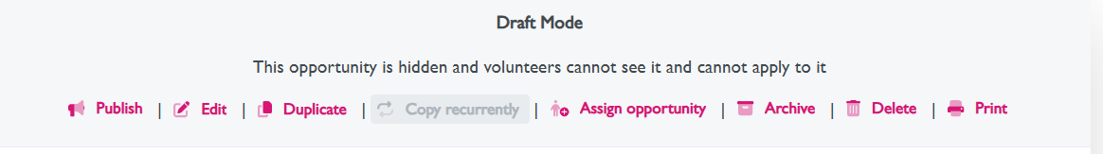
Figure 8: The Draft Mode banner. Select Publish to make your role live.
The banner shows you the status of your role. A white banner means the role is a draft: it is hidden, and volunteers cannot see it or apply to it. A green banner means the role has been published.

Need help?
If you get stuck, have a question, or would like to know more about anything this guide does not cover, such as editing, duplicating or archiving a role, please email the Volunteer Centre team at volunteercentre@voluntarynorfolk.org.uk.

